EXPERIMENT 21
Implement the Opening Technique as a Morphological Operation Using OpenCV
Aim:
To perform the Opening morphological operation on an image using Python and OpenCV.
Procedure:
- Import OpenCV and NumPy libraries.
- Read the input image.
- Convert the image into grayscale.
- Create a kernel using np.ones().
- Apply opening using cv2.MORPH_OPEN.
- Display the original and output images.
Program:
import cv2
import numpy as np

img = cv2.imread('image.jpg', 0)

kernel = np.ones((5,5), np.uint8)

opening = cv2.morphologyEx(img, cv2.MORPH_OPEN, kernel)

cv2.imshow('Original Image', img)
cv2.imshow('Opening Image', opening)

cv2.waitKey(0)
cv2.destroyAllWindows()
Input;

Output;
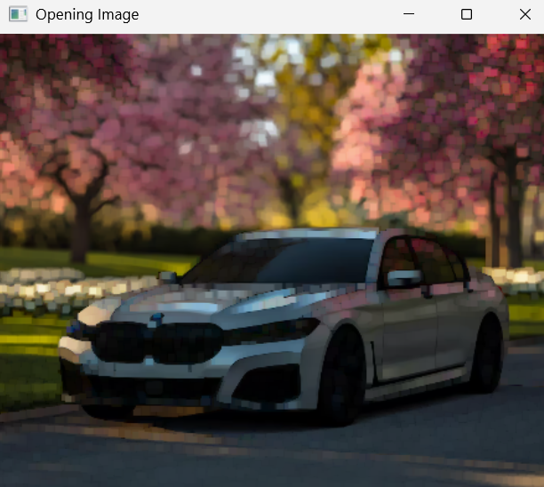
Result:
Thus, the Opening morphological operation was successfully performed using Python and OpenCV.

